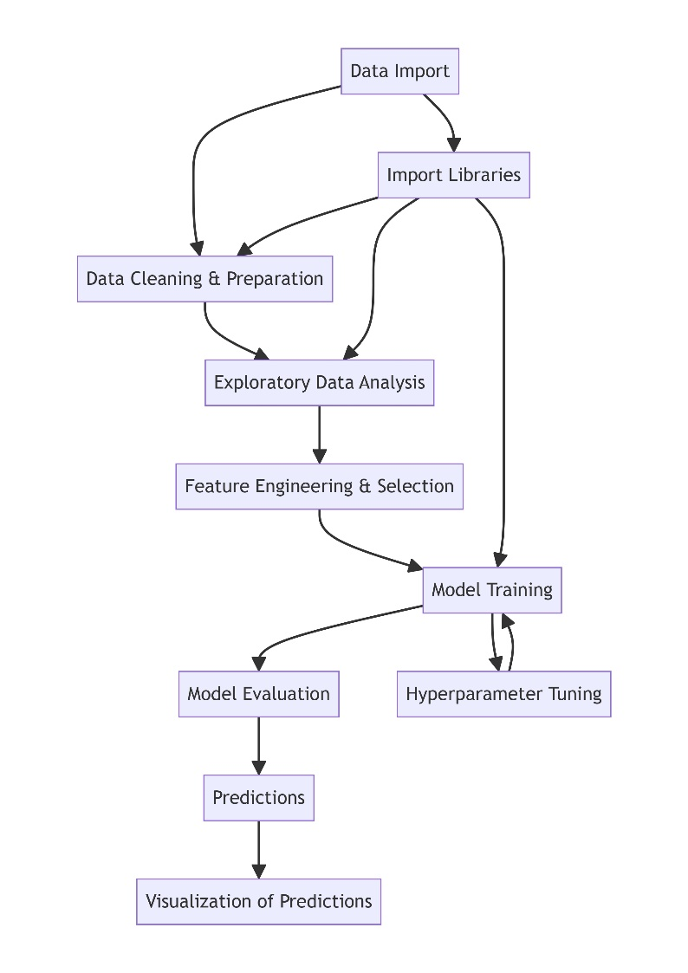**Flowchart**

**Q.** Why should we take ac power and dc power for weather prediction?

**1. Efficiency and Conversion Losses:** Solar panels generate DC power, which is then converted to AC power for grid usage. Analyzing both can help identify conversion losses and system efficiency, which may be affected by weather conditions.

**2. System Performance:** Understanding how weather impacts both the raw DC output of the panels and the final AC output after conversion can provide a complete picture of system performance under various weather conditions.

**3. Prediction Accuracy:** Including both AC and DC power data improves the accuracy of models predicting energy production. Weather conditions directly affect the DC power generation, and knowing how this translates to AC power can refine predictions.

**4. System Optimization:** Data on AC and DC power helps in optimizing the entire solar power system for better performance under different weather scenarios, ensuring maximum energy yield.

**Q.** How daily yield and total yield counted?

**Daily Yield** refers to the amount of electrical energy generated by a solar power system in a single day.

Calculation:

* The energy output (usually in kilowatt-hours, kWh) is continuously monitored throughout the day.
* The total energy generated over the course of the day is summed up to give the daily yield.

**Total Yield** refers to the cumulative amount of electrical energy generated by the solar power system over its operational lifetime or a specific period.

Calculation:

* The total yield is the sum of all daily yields over the period of interest.
* For lifetime yield, the daily yields are summed from the system's start date to the current date.

**Q.** What is unit of irradiance?  
 **Watts per square meter (${W/m}^{2}$)**

**Q.** Input Features:

**Date and Time Information**: DATE, TIME, BLOCK

**Weather Parameters:**

AMBIENT_TEMPERATURE: The temperature of the surrounding environment.

MODULE_TEMPERATURE: The temperature of the solar panel/module.

IRRADIATION: The solar irradiance, measured in watts per square meter (W/m²).

**Power:**

AC_POWER: The amount of alternating current power generated.

DC_POWER: The amount of direct current power generated.

**Q.** DATABASE COLLECTION SITE:

<https://www.kaggle.com/datasets/anikannal/solar-power-generation-data>